s

BRACT’S, Vishwakarma Institute of Information Technology, Pune- 48

# (An Autonomous Institute affiliated to Savitribai Phule Pune University)

**(NBA and NAAC accredited, ISO 9001:2015 certified)**

**DEPARTMENT OF CIVIL ENGINEERING**

**ACADEMIC YEAR 2023-2024**

**PROJECT** **REPORT ON**

## STUDY OF MANUFACTURING FOR SIPOREX AAC BLOCKS & PAVER BLOCKS

## THE GUIDANCE OF

## (AMOL LADHE)

## Submitted By : -

|  |  |  |
| --- | --- | --- |
| **Sr No.** | **Name of Group Members** | **PRN No.** |
| **1.** | **Krushna babar** | **22110427** |
| **2.** | **Atharv Kambale** | **22110239** |
| **3.** | **Harshali babar** | **22220214** |
| **4.** | **Akhliesh giram** | **22110919** |
| **5.** | **Prerna darade** | **22110397** |

**DEPARTMENT OF CIVIL ENGINEERING**

**BRACT’S, Vishwakarma Institute of Information Technology, Pune- 48**

**(An Autonomous Institute affiliated to Savitribai Phule Pune University)**

**(NBA and NAAC accredited, ISO 9001:2015 certified)**

**CERTIFICATE**

This is to certify that  **( 22110427 , 22220214 ,22110397, 22110239 , 22110919 )** has successfully completed the Project entitled

“ STUDY OF MANUFACTURING FOR SIPOREX AAC BLOCKS & PAVER BLOCKS ” under my supervision, in the partial fulfillment

of Bachelor of Technology

Degree in Civil Engineering the academic year 2023-24.

Date: 7-12-2023

Place: VIIT, Pune

(Guide)

Dr. Shrikant Shinde Dr. Vivek. S. Deshpande (Head of Department) (Director)

(External Examiner)

**UNDERTAKING BY STUDENTS**

We, the students of T.Y. B Tech. (Civil Engineering) hereby assure that we will follow all the rules and regulations of VIIT related to the project work for the academic year 2023-24 semester V and VI. The Project entitled **“STUDY OF MANUFACTURING FOR SIPOREX AAC BLOCKS & PAVER BLOCKS ”** will be fully executed by us and no part of the project/ full project will be designed and developed by any external entity or copied from some external resources. We are fully aware that copying or taking help of any external agency in the development of our project is totally unethical and illegal. The examiners have /University has full rights to initiate an action against us as per university norms if involved in unfair/ illegal/ unethical work.

|  |  |  |  |
| --- | --- | --- | --- |
|  |  |  |  |
|  |  |  |  |
|  |  |  |  |
|  |  |  |  |
|  |  |  |  |
|  |  |  |  |

|  |  |  |
| --- | --- | --- |
| **Sr No.** | **Name of Group Members** | **PRN No.** |
| **1.** | **Krushna babar** | **22110427** |
| **2.** | **Atharv Kambale** | **22110239** |
| **3.** | **Harshali babar** | **22220214** |
| **4.** | **Akhliesh giram** | **22110919** |
| **5.** | **Prerna darade** | **22110397** |

# TABLE OF CONTENTS

|  |  |
| --- | --- |
| **SR. NO.** | **TITLE** |
| **1** | **ABSTRACT** |
| **2** | **CHAPTER 1: INTRODUCTION** |
| **3** | **CHAPTER 2 : LITERATURE REVIEW** |
| **4** | **CHAPTER 3 : AIM & OBJECTIVES OF STUDY** |
| **5** | **CHAPTER 4 : METHODOLOGY** |
| **6** | CHAPTER 5 : PROJECT EXECUTION |
| **7** | **CHAPTER 6 : SCHEDULE OF THE PROJECT** |

**ABSTRACT**

This project aims to conduct a thorough examination and assessment of Autoclaved Aerated Concrete (AAC) blocks and pavement blocks, essential components in modern construction practices. The research encompasses a series of diverse tests to evaluate the structural, thermal, and durability properties of AAC blocks, alongside an in-depth analysis of the mechanical performance and interlocking capabilities of pavement blocks.

The structural analysis involves assessing the compressive strength, flexural strength, and density of AAC blocks, with a focus on understanding their load-bearing capacities and overall stability. Concurrently, pavement blocks will undergo rigorous testing to determine their resistance to wear, abrasion, and environmental factors, ensuring their suitability for various outdoor applications.

Furthermore, thermal conductivity tests will be conducted on AAC blocks to gauge their insulation properties, contributing to sustainable construction practices. In the case of pavement blocks, the interlocking mechanisms and load distribution efficiency will be investigated to enhance their suitability for paving projects.

The project's ultimate goal is to provide valuable insights into the performance characteristics of AAC blocks and pavement blocks, enabling informed decision-making for architects, engineers, and construction professionals. The findings from this comprehensive testing will contribute to the optimization of material selection and the enhancement of construction methodologies, promoting sustainability and durability in the built environment.

**CHAPTER 1: INTRODUCTION**

1. **For C4x Block : -**

Autoclaved Aerated Concrete (AAC) blocks have emerged as a revolutionary building material, offering a lightweight and environmentally friendly alternative to traditional construction materials. As the demand for sustainable and energy-efficient construction solutions grows, the significance of AAC blocks becomes increasingly apparent.

This project aims to conduct a thorough examination of AAC blocks through a series of comprehensive tests, focusing on key performance indicators such as compressive strength, thermal conductivity, sound insulation, and durability. By scrutinizing these aspects, we seek to provide valuable insights into the suitability and reliability of AAC blocks in diverse construction applications.

Through a meticulous testing process, this project aims to contribute valuable data that can inform builders, architects, and construction professionals about the structural and functional capabilities of AAC blocks. The results obtained will not only enhance our understanding of AAC block properties but also guide future construction practices towards more sustainable and resilient building solutions.

Join us on this exploration as we delve into the world of AAC blocks, unraveling their potential to redefine the future of construction by balancing efficiency, environmental consciousness, and structural integrity.

1. **For Paver Blocks : -**

The history of Concrete Paving Block dates back to 19th Century when paving stones were used in European countries for construction of roads serving as footpath sand tracks for steel-wheeled vehicles Interlocking Concrete Block Pavement(ICBP), an environment friendly and labour intensive technology, has been developed at CRRI, for providing pavements in areas where conventional types of construction are less durable due to many technical and environmental constraints. Concrete paver blocks were first introduced in Holland in the fifties as replacement of paver bricks which had become scarce due to the post-

war building construction boom.

**.**

**CHAPTER 2 : LITERATURE REVIEW**

To conduct a literature review on ACC (Adaptive Cruise Control) block testing, consider exploring research articles, journals, and conference papers related to automotive engineering, autonomous vehicles, and ACC systems. Focus on studies that discuss testing methodologies, performance evaluation, and validation techniques for ACC blocks. Look for key themes such as sensor integration, real-world testing scenarios, and reliability assessments in the context of ACC functionality. Additionally, explore recent advancements in testing frameworks and simulation tools applicable to ACC block testing.

A Concrete paver blocks were first introduced in Holland in the fifties as replacement of paver bricks which had become scarce due to the post-war building construction boom. These blocks were rectangular in shape and had more or less the same size as the bricks. During the past five decades, the block shape has steadily evolved from noninterlocking to partially interlocking to fully interlocking to multiply interlocking shapes. Paver blocks consists of a surface layer of small-element, solid

un-reinforced pre-cast concrete paver blocks laid on a thin, compacted bedding material which is constructed over a properly profiled base course and is bounded by edge restraints/kerb stones.

The block joints are filled using suitable fine material. The pioneering work of Balado (1965) in South America, Marais

(1967) in South Africa, and Netherlands was unknown in Australia. Accordingly, many of the early design and construction recommendations for concrete block paving.

The scope of work includes manufacturing ,supplying and laying of precast paver blocks of strength and quality as specified at various Retail outlets. C. F. Morrish, Executive Officer of the Concrete Masonry Association of Australia (CMAA), advised the industry to consider the manufacture of concrete block paving. Shortly thereafter, Adelaide City Council began to evaluate trial areas of pavement to determine their

suitability for use in the Rundle Street mall.

# CHAPTER 3 : AIM & OBJECTIVES OF STUDY

# 3.1 AIM : To check the Durability and Strength of AAC block and Paver block

# 3.2 OBJECTIVES:

* + 1. **Collect information about AAC and Paver Block**
    2. **Site visit**
    3. **Testing of Block**

# CHAPTER 4: METHODOLOGY

# 

**CHAPTER 5 : PROJECT EXECUTION**

**Collect Information about AAC block and paver block :**

Autoclaved aerated concrete (AAC) is a lightweight, precast, cellular concrete building material, eco-friendly, suitable for producing concrete-like blocks. It is composed of quartz sand, calcined gypsum, lime, portland cement, water and aluminium powder. AAC products are cured under heat and pressure in an autoclave.

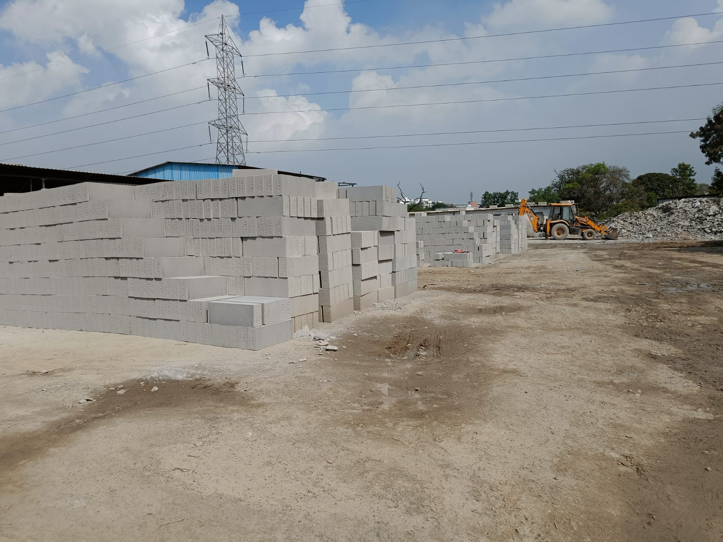

**Paver block :**

Paver blocks, sometimes referred to as brick paving, are a popular decorative option for laying pavement. Paver blocks are small, flat, interlocking blocks used in construction.

They are made from a combination of cement, sand, and aggregate. Paver blocks are strong, durable, and can withstand heavy loads and traffic.

They are also slip-resistant and skid resistant.

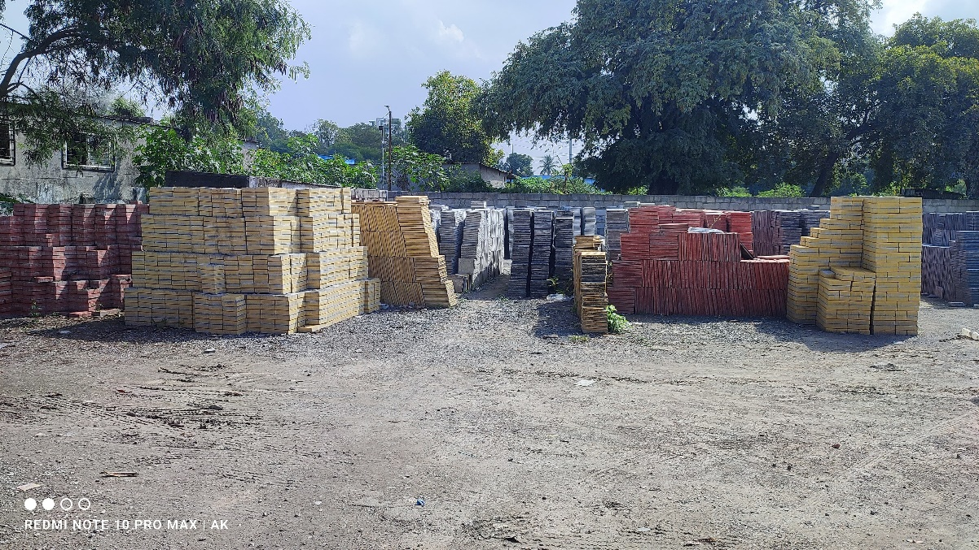

**Paver blocks are used for:**

* Pavements,
* Walls,
* Pillars,
* Driveways,
* Pathways,
* Patios,
* Retaining walls.
  1. Paver blocks are available in a variety of colors, sizes, shapes, and textures.
  2. They are typically 4 x 8 inches (100 x 200 mm) in size, with thicknesses from 2 1/2 to 4 inches (60 to 100 mm).
  3. Paver blocks are easy to install and don't require any special equipment. They can be used in any weather conditions and can be easily replaced. Paver blocks have a lifespan of at least 20 years.

# 

# Site Visit : -

We have visited **Alpine AAC Block Limited** to take a overview about AAC Block and Paver block. How they are manufactured and stored.

Here is information we collected from site:

* **For Acc block** : -

1 Batch process = 13 Mould of (1000 kg per Mould)

**Process For 1 Mould**

1. Material

* Fly Ash slurry = 800 kg
* Cement =100 kg
* Limestone = 45 kg
* Aluminum Powder = 360 gm
* Soluble Oil = 600 gm
* Gypsum = 6 kg
* Mould oil = 5 litre

1. Then mixing of all material in grinder and mixer.
2. After mixing it is taken towards steam area for almost 5 min.
3. The heating of mould take place for 3 hour at 70 degree Celsius.
4. In mould slurry is filled up with ¾ and pluff up.
5. After moulding it goes to demoulding.
6. After in boiler we make steam & transfered for autoclaving.
7. For Steaming & pressure purpose total 12 hr are required for autoclaving process.
8. Then blocks are ready for Transportation.

In one mould

5 inch = 51 blocks are formed . Weight per : - 16 to 14 kg

6 inch = 42 blocks are formed . Weight per : - 24 kg.

* **For Paver Block : -**

**Types of Paver Block : -**

1. **In 60 mm Thickness : -**
2. **4 square Block**
3. **Parking Tiles**
4. **Rectangular Block**

**B .In 25 mm thickness : -**

1 . Combi

2 . 4 Square

3 . z – line

4 . 9 square

* **Process : -**

1 . 10 mm Aggregates .

2 . Crushent Powder .

3 . Cement above M30 used .

4 . Colour Pigment : - Red , Yellow , Black , Grey .

5 . Basic Chemicals Used to mix Ingredients Properly .

6 . This Mixture are Poured in mould of given sizes .

7 . They are stored for 24 hr to gain strength and

8 . Finally they are packed for selling purpose or to transport .

For One mould : -

4 “ – 64 (same ratio )

5” - 52 (same ratio )

6” - 42 (same ratio )

8” - 38 (same ratio )

9” - 28 (same ratio )

**To check Strength of Blocks we have Performed specific Test : -**

A . Process for compression Test :-

**Compression Test Procedure on UTM**

Conducting a compression test on a Universal Testing Machine (UTM) involves the following general procedure:

**Prepare the Specimen:**

Cut or prepare the specimen according to the required dimensions and shape.

Ensure the specimen is clean and free from any defects.

**Install the Specimen:**

Place the specimen between the compression plates of the UTM.

Align the specimen carefully to avoid any lateral forces during testing.

**Set Test Parameters:**

Configure the UTM to the desired compression test parameters (e.g., load rate, target load, etc.).

Ensure the UTM is calibrated and properly configured for accurate measurements.

**Zero the Load Cell:**

If applicable, zero the load cell to account for any initial load on the system.

**Start the Test:**

Initiate the compression test using the UTM control panel or software.

Monitor the test to ensure proper alignment and behavior of the specimen

.

**Record Data:**

Record relevant data during the test, including load (force) and displacement measurements.

Capture data at regular intervals or continuously depending on the test requirements.

**Continue Testing**:

Allow the UTM to continue applying force until the specimen fails or until reaching the desired endpoint.

**Analysis of Results:**

Analyze the recorded data to determine compressive strength, modulus of elasticity, and other relevant properties.

Plot load versus displacement curves if needed.

**Repeat if Necessary:**

If required, repeat the test with additional specimens to ensure reliability and consistency of results.

* Result : -
* **For AAC Block : -**

1 . 650 x 240 x 120 mm : -

Load Bearing Capacity : -  **589.743 x 10^-3 N/mm^2**

2 . 650 x 240 x 200 mm : -

Load Bearing Capacity : - **596.153 x 10 ^-3 N/mm^2**

**For Paver Blocks :-**

**1 . Black colour : -**

Load Bearing Capacity : - **7. 33 x 10^ -1 N/mm^2**

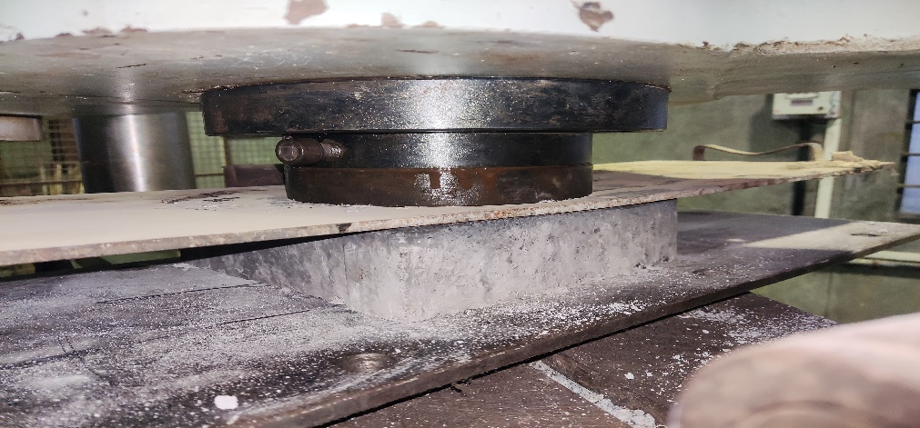

**2 .Yellow Colour** : -

Load Bearing Capacity : - 9 **x 10^-1 N/mm^2**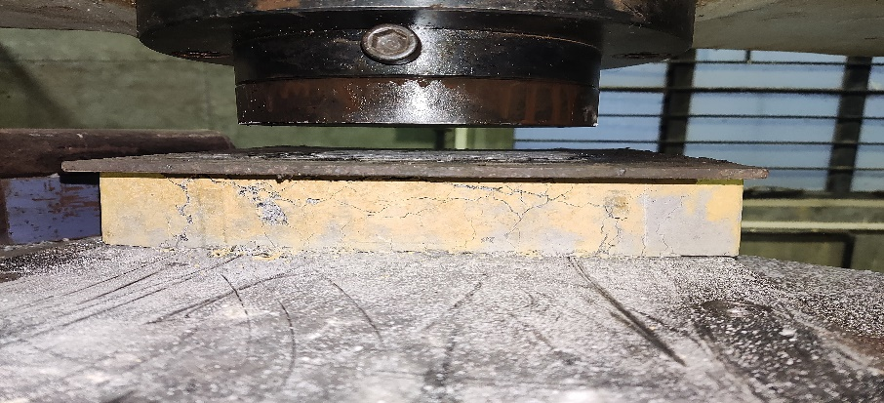

**3 . Red Block ( College Premises ) : -**

Load Bearing Capacity : -  **8 x 10^-1 N/mm^2**

# CHAPTER 5: SCHEDULE OF THE PROJECT

|  |  |  |  |  |  |
| --- | --- | --- | --- | --- | --- |
| Sr. No | Activities | July-September | October- December | January- March | April-June |
| 1 | Consultation with guide | Week 1 |  |  |  |
| 2 | Research on Topic | Week 2 |  |  |  |
| 3 | Fixing of Topic | Week 3 |  |  |  |
| 4 | Collected Literature  Review | Week 4 |  |  |  |
| 5 | Deciding the Aim &  Objectives |  | Week6 |  |  |
| 5 | Research on objectives |  | Week7 |  |  |
| 6 | Finalization of conclusion |  | Week8 |  |  |
| 7 | Permission for Site visit |  | Week 12 |  |  |
| 8 | Site Visit and Testing For strength |  | Week 13 |  |  |
| 9 | Report Submission |  | Week14 |  |  |

* **REFERENCES**

1. IS 2185-3 (1984): concrete masonry units, Part 3 <https://law.resource.org/pub/in/bis/S03/is.2185.3.1984.pdf>
2. IS 15658 (2006): Precast concrete blocks for paving - <https://law.resource.org/pub/in/bis/S03/is.15658.2006.pdf>
3. <https://www.researchgate.net/publication/324438367_Strength_and_Durability_of_Concrete_Paver_Block>
4. Web search , chat GPT , & Other Net Browsers !

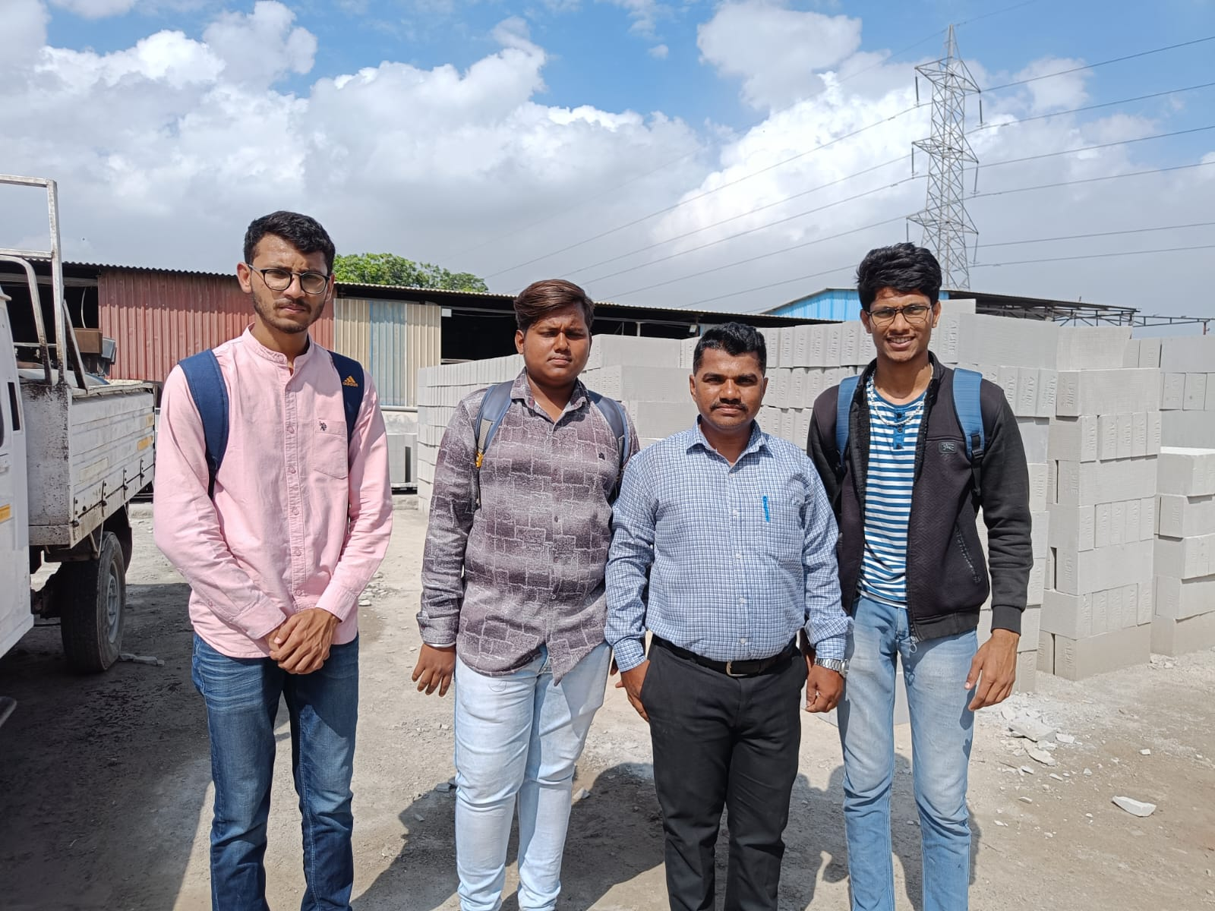Site Visit : -